Contact Management System – Project Documentation

1. Project Overview

📌 Description
The Contact Management System is a Python-based console application designed to efficiently store, manage, and retrieve contact information. It allows users to add, search, update, delete, and display contacts using a dictionary-based data structure with persistent storage.

🎯 Project Goals & Objectives
- Provide an easy-to-use interface for managing contacts
- Store contact data persistently using JSON files
- Implement CRUD (Create, Read, Update, Delete) operations
- Ensure data accuracy using input validation
- Enable partial searching by name or phone number
- Demonstrate clean code structure and testing practices

🎯 Features
✓- Add new contacts with validation
✓- Search contacts by name (partial matching supported)
✓- Update existing contact information
✓- Delete contacts with confirmation
✓- View all contacts in formatted display
✓- Save contacts to JSON file automatically
✓- Load contacts from file on startup
✓- Export contacts to CSV format
✓- Contact statistics and analytics
✓- Phone number and email validation
✓- User-friendly menu interface
✓- Error handling for all operations

2. Setup Instructions

🛠 Requirements
- Python 3.8 or higher
- No external libraries required (uses Python standard library only)

📥 Installation Steps
- Clone or download the project repository:
- git clone <repository-url>
- Navigate to the project directory:
- cd week3-contact-manager
- Ensure Python is installed:
- python --version

▶️ Running the Application
python contacts_manager.py

🧪 Running Tests
python test_contacts.py

3. Code Structure

📁 File Hierarchy
week3-contact-manager/
│── contacts_manager.py # Main application logic
│── contacts_data.json # Persistent contact storage
│── test_contacts.py # Unit tests
│── README.md # Project documentation
│── requirements.txt # Dependencies
└── .gitignore # Ignored files

🧩 File Responsibilities
- contacts_manager.py
Contains validation functions, CRUD operations, file handling, menu system, and program entry point.
- contacts_data.json
Stores contact data in JSON format for persistence.
- test_contacts.py
Contains unit tests for validation logic.
- README.md
Provides project documentation and usage instructions.

4. Visual Documentation

📸 Application Screens 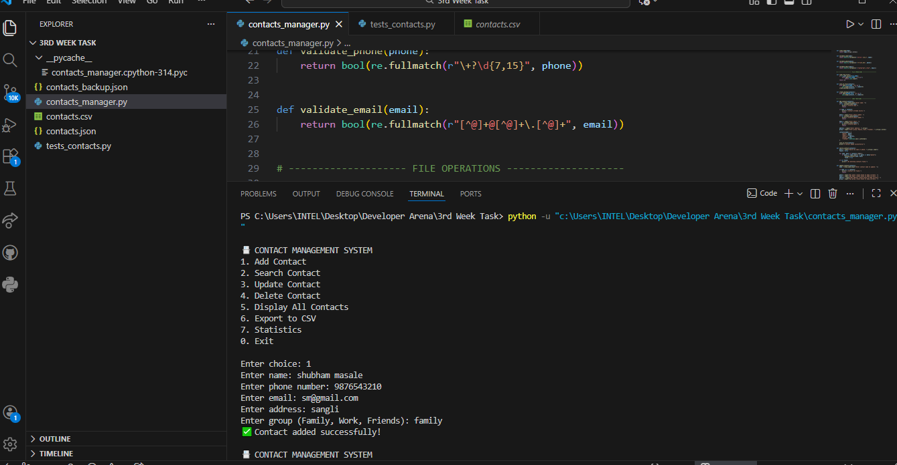

Search Result Example
Swapnali masale → {'phone': '+9284265192', 'email': 'swapnalim@gmail.com', 'group': 'Family'}

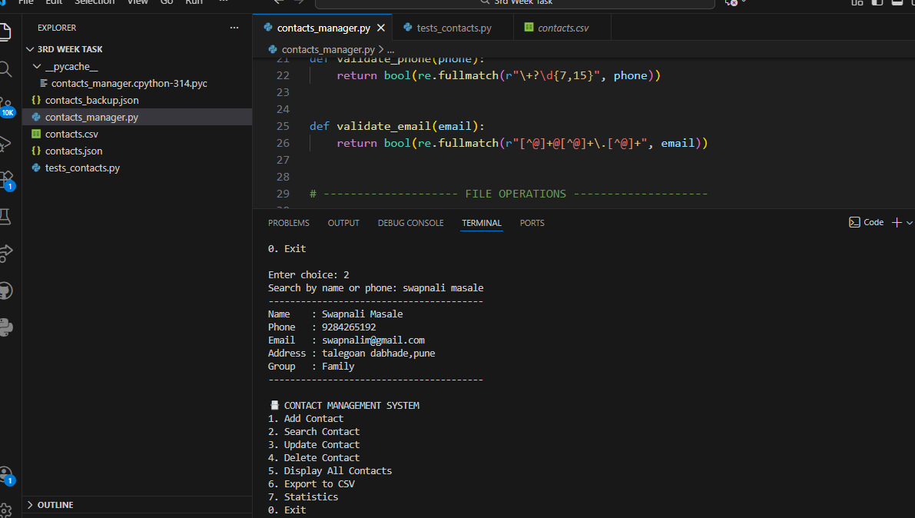
Display All Contacts
Swapnali masale → {'phone': '+9284265192', 'email': 'swapnalim@gmail.com', 'group': 'Family'}
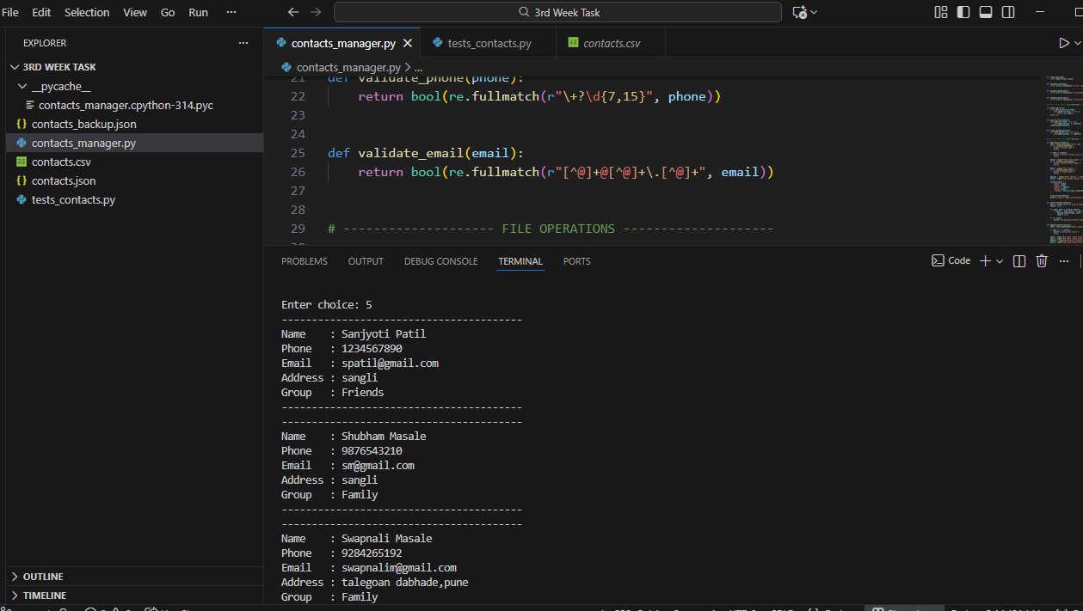

5. Technical Details

🧠 Data Structures Used
- Dictionary
- contacts = {
- "Swapnali Masale": {
- "phone": "+9284265192",
- "email": "swapnalim.com",
- "group": "Family"
- }
- }
- Nested dictionaries store detailed contact information.

⚙️ Algorithms & Logic
- Validation using regular expressions (regex)
- Partial search using substring matching
- CRUD operations implemented via dictionary manipulation
- File persistence using JSON serialization
- Backup creation during save operations

🏗️ Architecture
- Procedural programming approach
- Separation of concerns:
  - Validation
  - File handling
  - Business logic
  - User interface

6. Testing Evidence

🧪 Testing Framework
- Python unittest module

✅ Sample Test Cases
def test_phone(self):
self.assertTrue(validate_phone("+1234567890"))
self.assertFalse(validate_phone("abc123"))
def test_email(self):
self.assertTrue(validate_email("test@example.com"))
self.assertFalse(validate_email("test@com"))

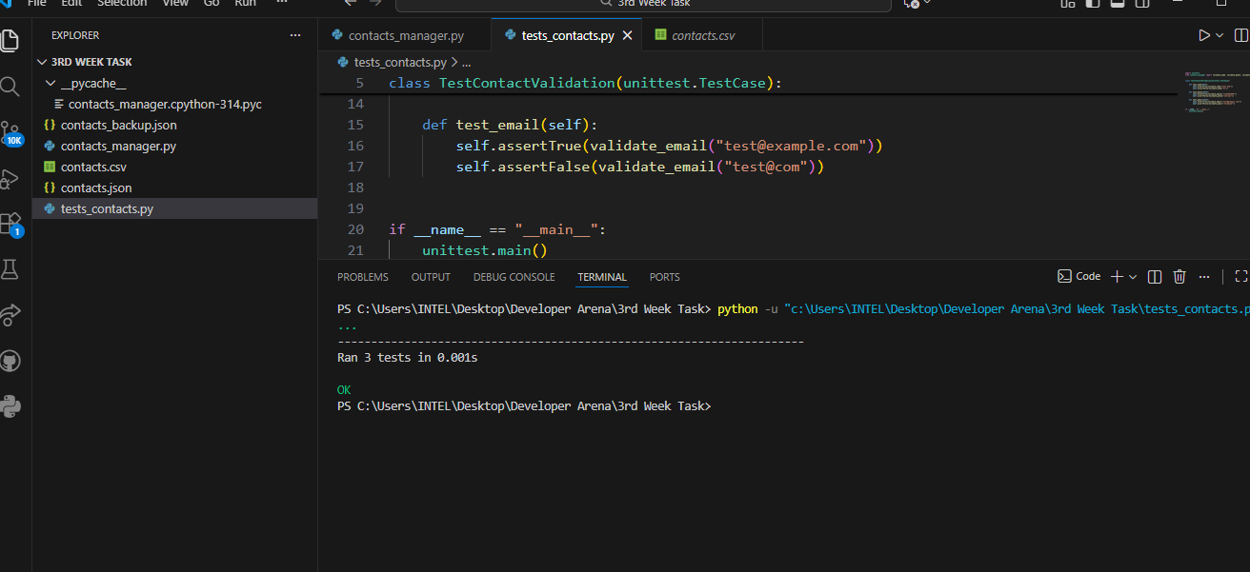

🧾 Validation Covered
- Name validation
- Phone number format
- Email format
- Edge cases (invalid input)

✔️ Test Results
- All tests pass successfully
- Validation logic works as expected
- Prevents invalid data entry

7. Conclusion
The Contact Management System successfully meets all project objectives by:
- Providing reliable contact storage
- Ensuring data validation and integrity
- Supporting persistent data handling
- Demonstrating clean code organization
- Including test-driven validation
This project serves as a solid foundation for future enhancements such as GUI integration, database storage, or cloud synchronization.

